 

Introduction to OneDrive

**March 2018**

# C:\Users\Administrator.SNPC71\Dropbox (SSD)\Stats4SD\Internal Docs\Stationery\Logos\Logo\Stats4SD_Logo_Red_Small.png

This document was produced in collaboration with [Statistics for Sustainable Development](https://stats4sd.org/) and is licensed under a [Creative Commons Attribution-NonCommercial-ShareAlike 3.0 Unported License](http://creativecommons.org/licenses/by-nc-sa/3.0/deed.en_GB).

# What is OneDrive?

OneDrive is a file-hosting service operated by Microsoft as part of its suite of online services. It allows users to store files in the cloud. Files can be synced to a PC and accessed from a web browser or a mobile device. Files can also be shared publicly or with specific individuals.

OneDrive is linked to your Microsoft account. It is built into Windows 10 and Windows 8.1 but if you have earlier versions of Windows you can download and install the OneDrive desktop app for Windows. OneDrive is also included with Office 365.

# Getting Started

As mentioned above, if you have Windows 10 or Windows 8.1 you will automatically have OneDrive on your PC. If you have Office 365, either the personal or business plans, you will also have OneDrive. If you are using an earlier version of Windows (Windows 7 for example), you can sign up for a free account. Go to <https://onedrive.live.com> and follow the link to **Plans**. From there you can sign up for a Free account which gives you 5GB of cloud storage space. You can buy additional space – see the various plans for further details.

# Working through your browser

Once you have signed in, you can manage your files and folders from your web browser. Figure 1 shows a typical view of what you will see through your browser.

Figure 1 - OneDrive through the web browser

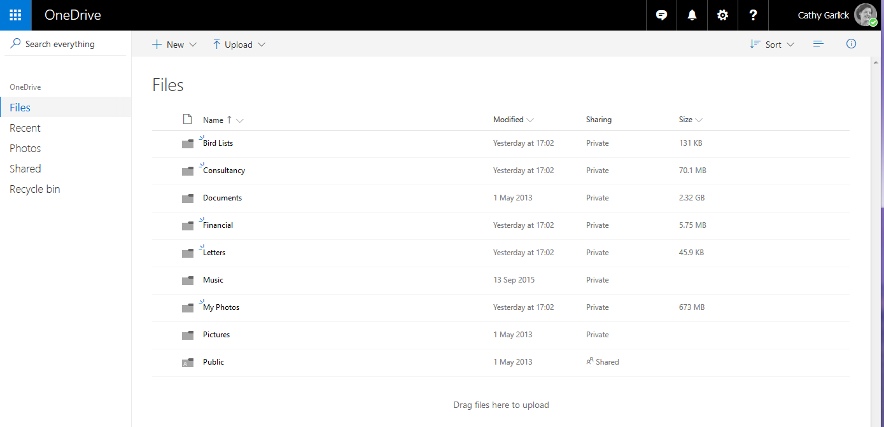

For any file is the list, the last modification date is shown. The **Sharing** column indicates whether the file is shared with others or whether it is private. In Figure 1 the only shared folder is the folder called **Public**.

# Uploading Files

To upload files, click on  and select Files or Folder as appropriate. This will open a typical Windows Open File dialogue box where you can locate and select the files or folder to upload. Note this will add a copy of the files to your OneDrive store. The file will be uploaded to the current folder in your OneDrive.

To update a file, click on **Upload files** in the right-hand column. This will take you to the standard Windows Open File dialog from where you can select a file to upload. The file will be uploaded to the current folder. If you later want to move it to a different folder then hover over the file name, click the 3 vertical dots that appear (see Figure **2**) and select **Move to** from the pop-up menu. Select the destination folder for the file from the list of folders you have available.

Figure 2 - Selecting a file in the list

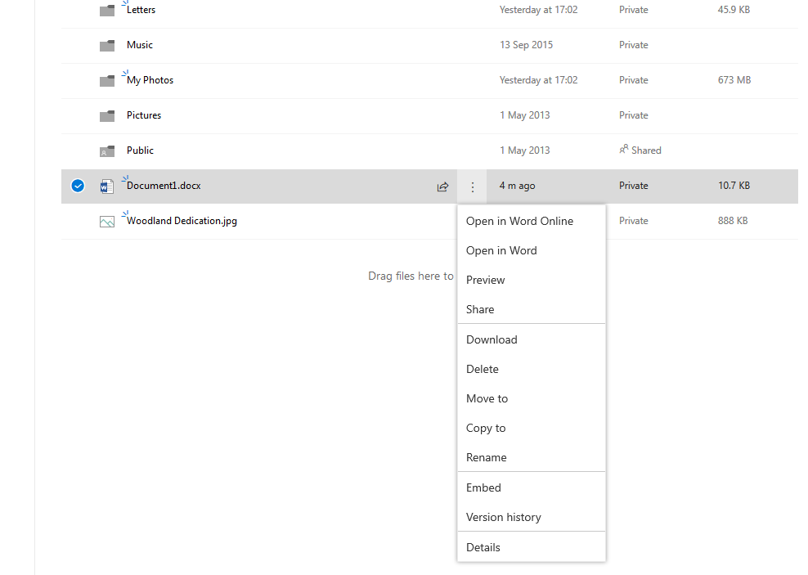

An alternative method for uploading files is simply to drag and drop from Windows Explorer, effectively treating your OneDrive folder as another folder on your hard drive.

# Sharing Folders

To share a folder, hover over the folder you want to share and click on the share icon as illustrated in Figure 3 – the Share icon will only appear when you hover over the folder.

Figure 3 - Share Icon

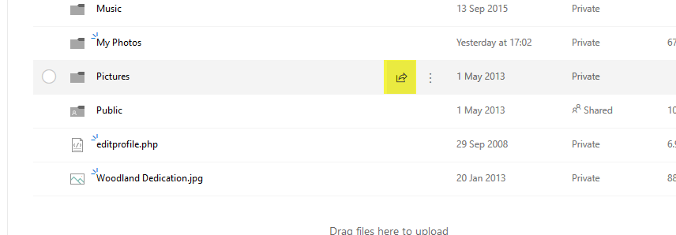

A dialog similar to that shown in Figure 4 will appear.

Figure 4 - Sharing a folder

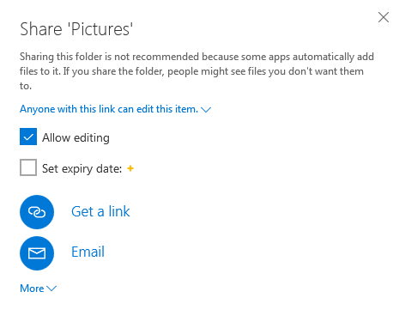

Click on **Get a link** for a unique link to be generated which you can then copy and email to individuals. You can allow or disable editing in the shared folder and there is an option to set an expiry date giving you the option of only sharing the folder for a limited time.

When you click on **Email** you can enter one or more email addresses and an optional message. Each person in the list will receive an invitation email with a link to follow.

## Checking and Changing the Member list

Once a folder is shared you can click on **Shared** in the **Sharing** column of the list to see who currently has access to the folder. From there you can easily add others to the shared list and again can choose whether individuals should have read/write access or just read access.

# Installing OneDrive

All the facilities we have looked at so far can be done through your web browser. If you have Windows 10, Windows 8.1 or Office 365 then a folder will appear on your computer which will automatically sync with the web version of your OneDrive. If you are using an earlier version of Windows and are not using Office 365, then you can install OneDrive. Figure 5 shows how the OneDrive folder appears in Windows Explorer.

Figure 5 - OneDrive folder on the PC

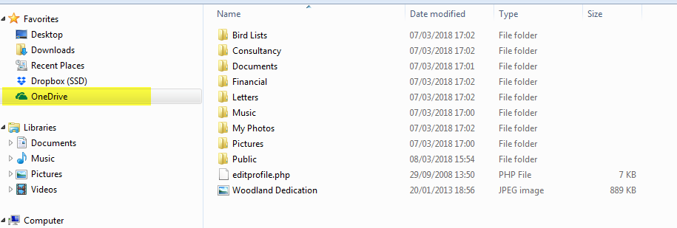

You can use this folder like any other folder on your computer. The only difference being that this folder will be available to you from wherever you are, provided you have an Internet connection.

Note: depending on how you are logged into your computer, you may need to give your Microsoft account details when you want to use OneDrive in this way

# Pricing & Storage Space

You can sign up to OneDrive for free – all you need is a Microsoft account. With this basic free account, you have up to 5GB of storage space. By paying a monthly fee you can buy 50GB of storage space. As already mentioned, OneDrive comes bundled with Office 365 and this package gives you up to 1TB of storage space.

For the current pricing please see the OneDrive website at <https://onedrive.live.com>

There are also some business plans available – see the website for details.